CLOSE ENDED 2

Q: What are the top 5 brands by sales among users that have had their account for at least six months?

Assumption: I am assuming that the column in final_sale in table TRANSACTIONS is inclusive of the quantity. This assumption will apply to all answers henceforth

-- a view of users who have been signed up for at least 6 months

WITH user_month6 AS (

SELECT *

FROM USER_TAKEHOME

WHERE ( (strftime('%Y', 'now') - strftime('%Y', created_date) >= 1 )

        OR

            (strftime('%m', 'now') - strftime('%m', created_date) >= 6 )

          )

),

--a view of transactions of people who have had their account for 6 months

transactions_month6 AS (

SELECT *

FROM TRANSACTION_TAKEHOME

WHERE user_id IN (SELECT id from user_month6)

)

/*Assuming top sales as the dollar amount of sales of each brand*/

SELECT p.BRAND, SUM(t.FINAL_SALE) AS Total

FROM transactions_month6 t LEFT JOIN PRODUCTS_TAKEHOME p on t.BARCODE = p.BARCODE

WHERE t.BARCODE IS NOT NULL AND p.BRAND is not NULL AND p.BRAND is NOT ''

GROUP BY p.BRAND

ORDER BY Total DESC

LIMIT 5;

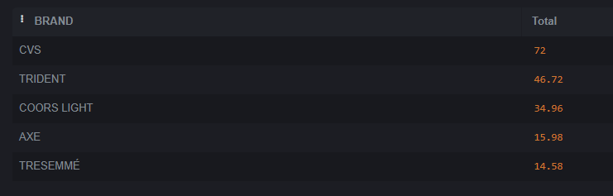

/*However as noted above there are some data issues resulting in the following as a the true top 5*/

